Task on CloudFront & Route 53
1: Configure VPC peering in cross regions.
VPC-A — N. Virginia (us-east-1)
- CIDR: 10.0.0.0/16
- Route table: VPC-A-RT
- Route to VPC-B: 20.0.0.0/16 → pcx-0cb3f6f26e2217aa4
VPC-B — N. California (us-west-1)
- CIDR: 20.0.0.0/16
- Route table: VPC-B-RT
- Route to VPC-A: 10.0.0.0/16 → pcx-0cb3f6f26e2217aa4
VPC Peering
- ID: pcx-0cb3f6f26e2217aa4
- Type: Cross-Region
- Status: Active ✅
A VPC peering connection pcx-0cb3f6f26e2217aa4 / VPC-A-to-VPC-B has been requested.
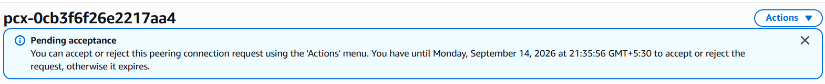
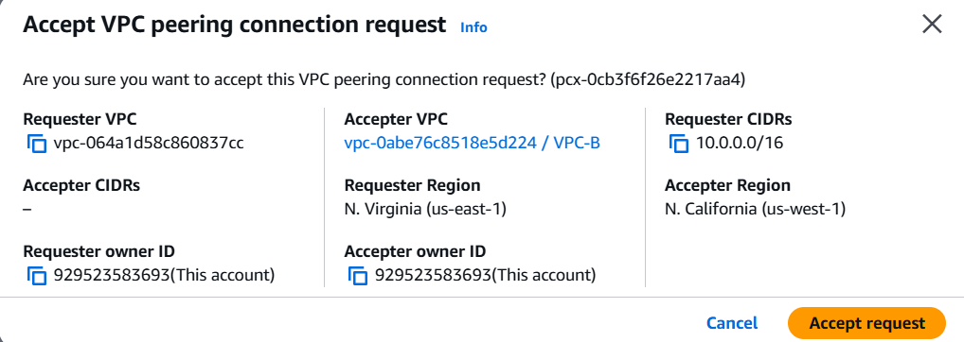
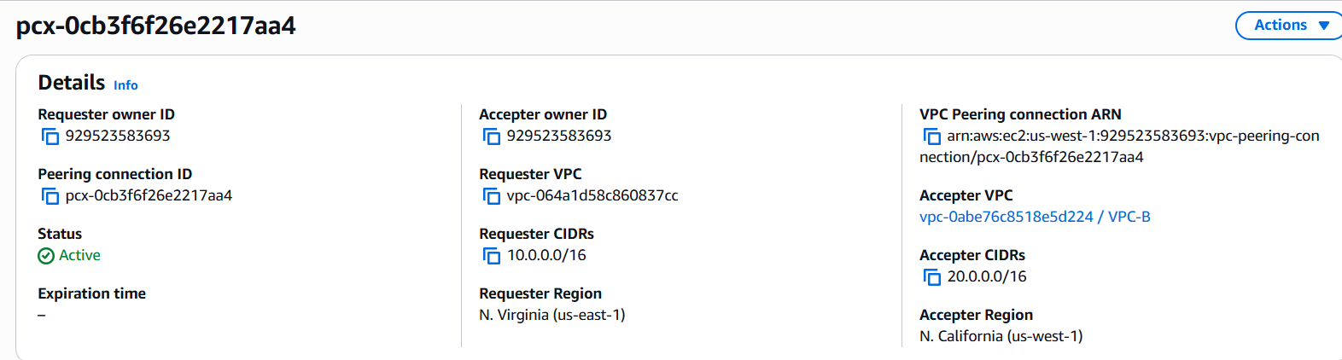
Route Tables:
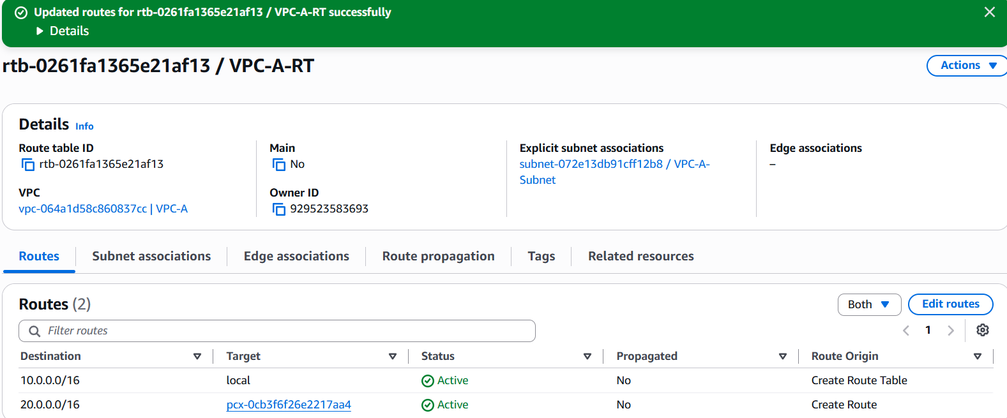

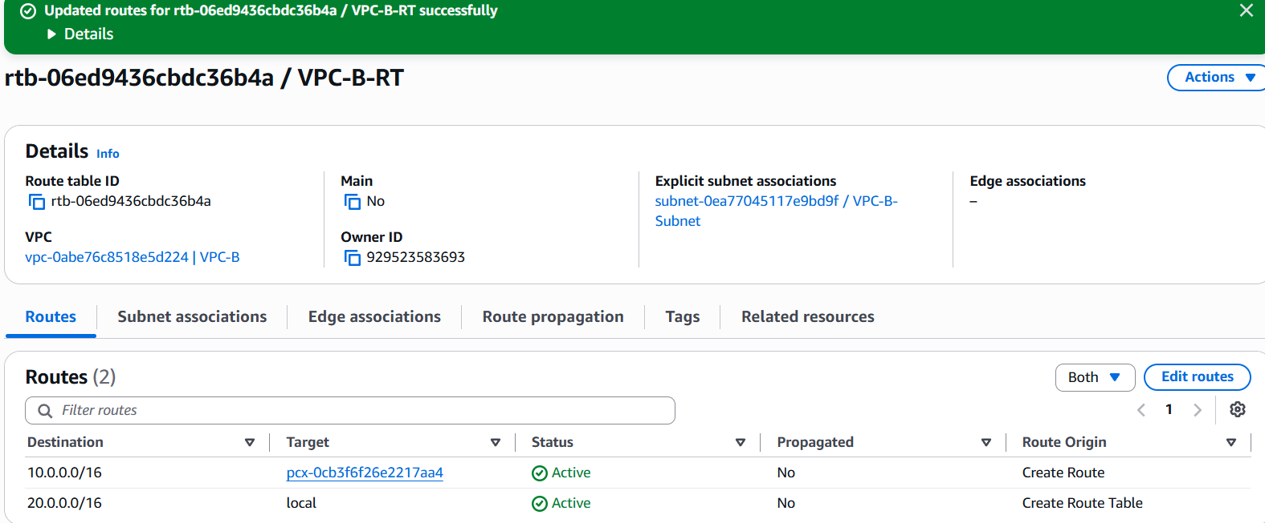

2: Purchase one domain from GoDaddy.
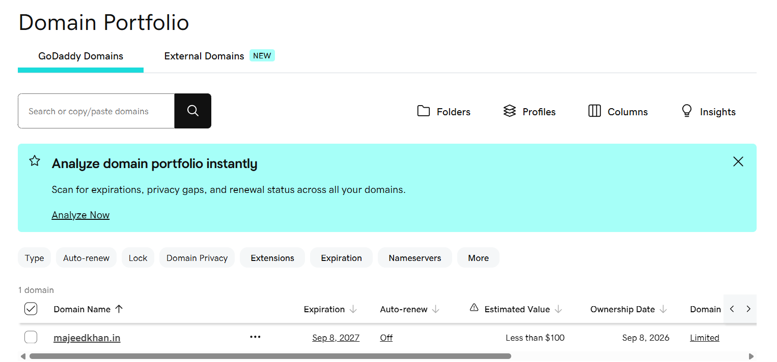
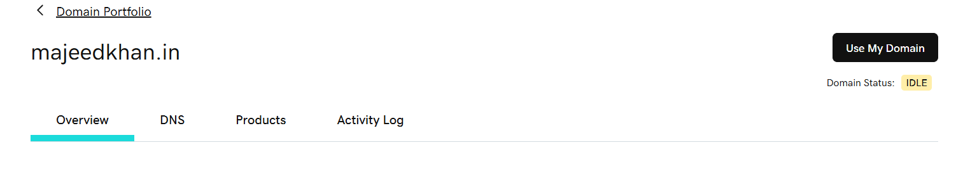
- majeedkhan.in is now in your GoDaddy Domain Portfolio.
3: Deploy static website in S3.
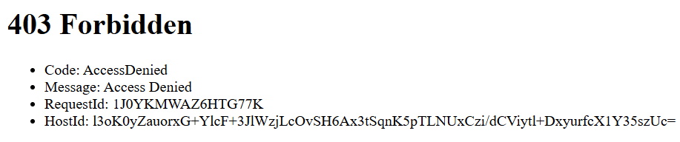
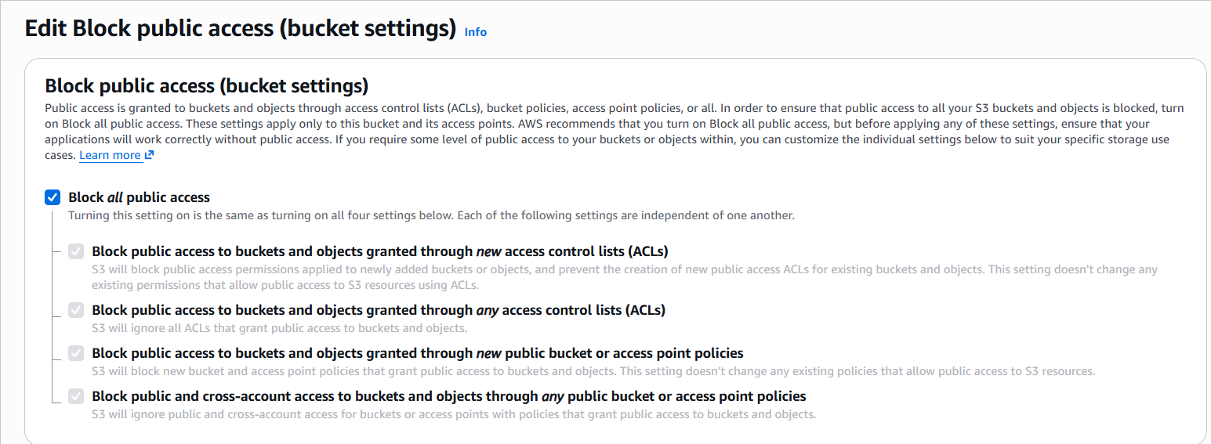
Check to uncheck public access
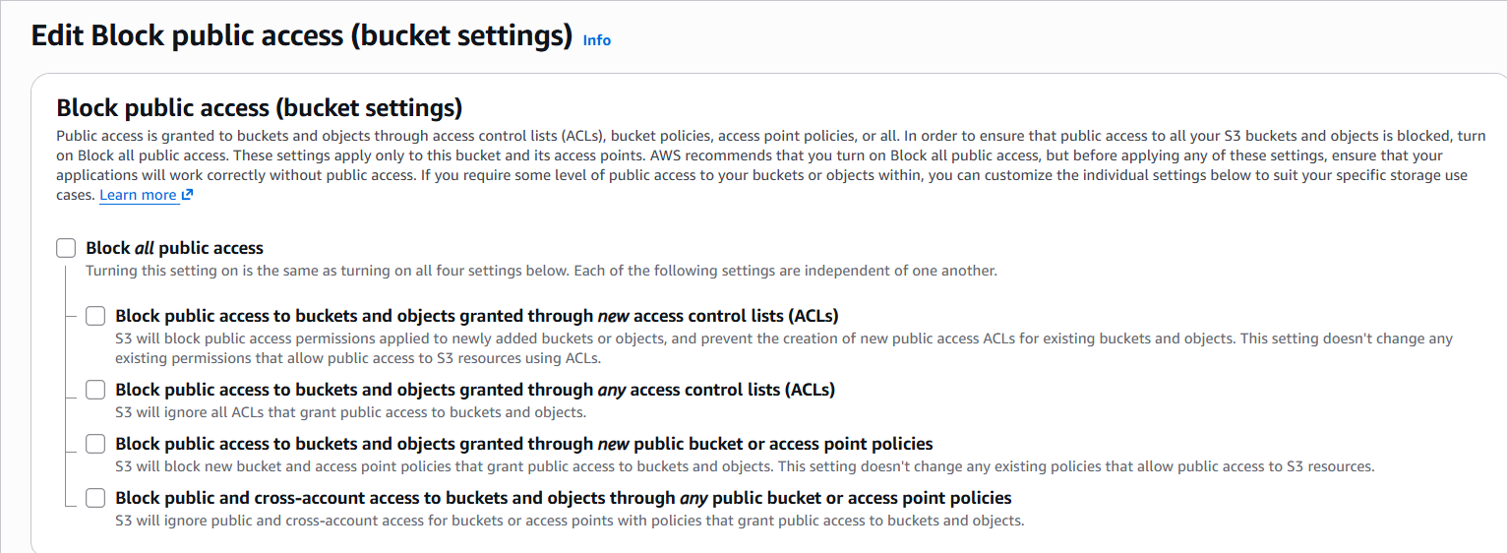
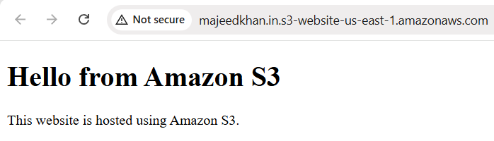
4: Create a CDN and attach one SSL certificate.
Step 1--Create a Route 53 Hosted Zone
Create hosted zone.
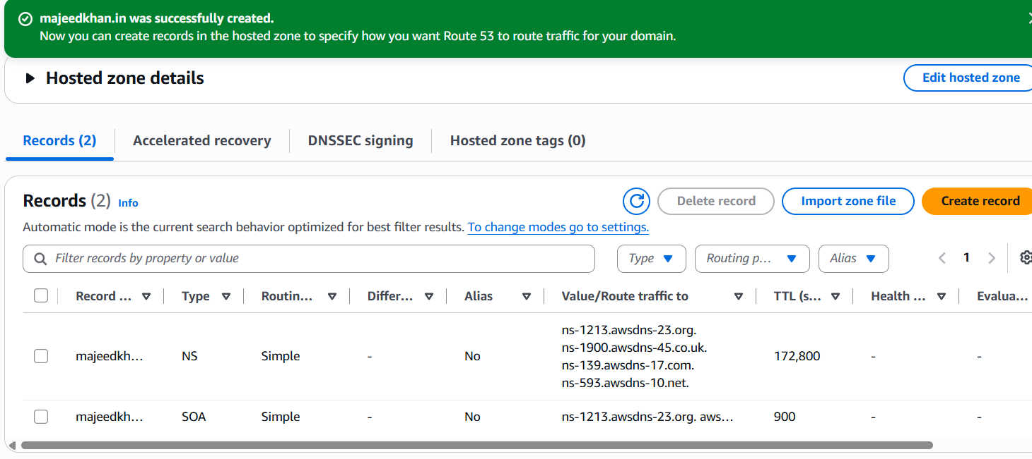
Step 2 — Update GoDaddy nameservers
GoDaddy → Domain Portfolio → majeedkhan.in → DNS → Nameservers.
Replace the existing GoDaddy nameservers with these 4 Route 53 nameservers shown in your screen:

ns-1213.awsdns-23.org
ns-1900.awsdns-45.co.uk
ns-139.awsdns-17.com
ns-593.awsdns-10.net Save the change.
Step 3 — Validate the ACM certificate
